TASK10:
Student Crud App
AIM: To develop a Student CRUD application using HTML, CSS, JavaScript, and Node.js to
perform create, read, update, and delete operations.
ALGORITHM:
1. Start the program
2. Create project files (HTML, CSS, JS, server.js, db.js)
3. Design UI for student input (id, name, course)
4. Apply CSS for styling and layout
5. Capture user input using JavaScript
6. Send data to server using fetch API
7. Create backend using Node.js and Express
8. Implement Create operation (POST request)
9. Implement Read operation (GET request)
10. Implement Update operation (PUT request)
11. Implement Delete operation (DELETE request)
12. Display updated student data dynamically and stop
PROGRAM:
INDEX.HTML:
<!DOCTYPE html>
<html>
<head>
<title>Student CRUD</title>
<link rel="stylesheet" href="style.css">
</head>
<body>
<div class="container">
<h2>Student CRUD</h2>
<input id="id" placeholder="ID">
<input id="name" placeholder="Name">
<input id="course" placeholder="Course">
<button onclick="addStudent()">Add</button>
<button onclick="updateStudent()">Update</button>
<ul id="list"></ul>
</div>
<script src="script.js"></script>
</body>
</html>
STYLE.CSS:
body {
font-family: 'Segoe UI';
background: linear-gradient(135deg,#1f1c2c,#928dab);
height: 100vh;
display:flex;
justify-content:center;
align-items:center;
color:white;
}
.container {
background: rgba(255,255,255,0.1);
padding:20px;
border-radius:10px;
text-align:center;
}
input {
display:block;
margin:8px auto;
padding:8px;
}
button {
margin:5px;
padding:8px;
background:#00c6ff;
border:none;
color:white;
}
SCRIPT.JS:
function addStudent() {
let data = getInput();
fetch("/add", {
method: "POST",
headers: {"Content-Type":"application/json"},
body: JSON.stringify(data)
}).then(loadStudents);
}
function loadStudents() {
fetch("/all")
.then(res => res.json())
.then(data => {
let list = document.getElementById("list");
list.innerHTML = "";
data.forEach(s => {
let li = document.createElement("li");
li.innerHTML = `
${s.id} - ${s.name} (${s.course})
<button onclick="deleteStudent(${s.id})"> </button>
`;
list.appendChild(li);
});
});
}
function updateStudent() {
let data = getInput();
fetch("/update", {
method: "PUT",
headers: {"Content-Type":"application/json"},
body: JSON.stringify(data)
}).then(loadStudents);
}
function deleteStudent(id) {
fetch(`/delete/${id}`, { method: "DELETE" })
.then(loadStudents);
}
function getInput() {
return {
id: document.getElementById("id").value,
name: document.getElementById("name").value,
course: document.getElementById("course").value
};
}
loadStudents();
SERVER.JS:
const express = require("express");
const cors = require("cors");
const db = require("./db");
const app = express();
app.use(cors());
app.use(express.json());
app.use(express.static(__dirname));
// CREATE
app.post("/add", (req, res) => {
db.add(req.body);
res.json({msg:"Added"});
});
// READ
app.get("/all", (req, res) => {
res.json(db.getAll());
});
// UPDATE
app.put("/update", (req, res) => {
db.update(req.body);
res.json({msg:"Updated"});
});
// DELETE
app.delete("/delete/:id", (req, res) => {
db.remove(req.params.id);
res.json({msg:"Deleted"});
});
app.listen(3000, () => console.log("http://localhost:3000"));
DB.JS:
let students = [];
function add(s) {
students.push(s);
}
function getAll() {
return students;
}
function update(updated) {
students = students.map(s =>
s.id == updated.id ? updated : s
);
}
function remove(id) {
students = students.filter(s => s.id != id);
}
module.exports = { add, getAll, update, remove };

OUTPUT :
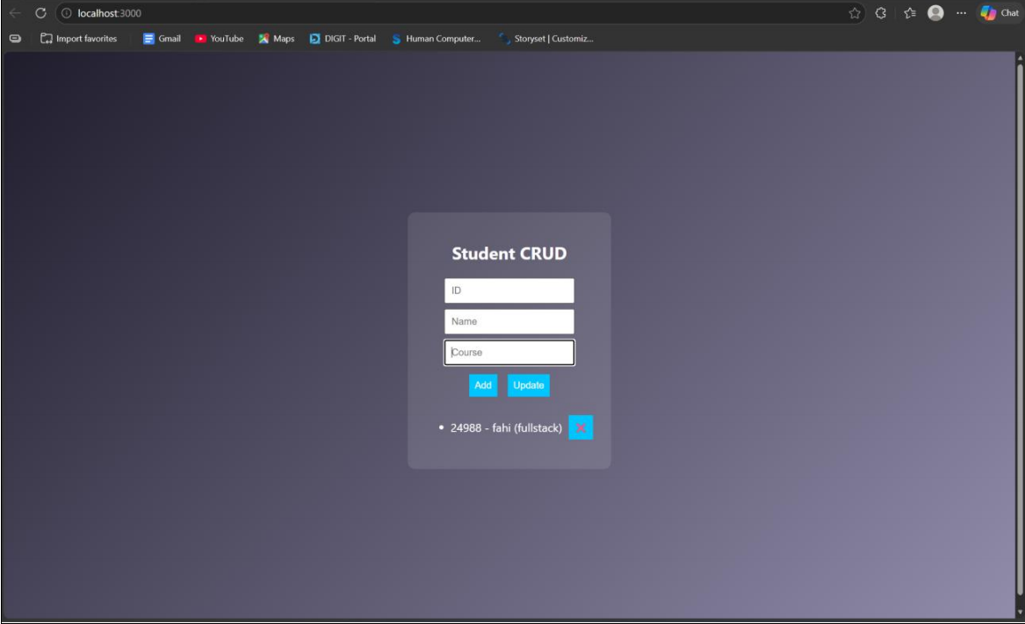
RESULT :
The Student CRUD application was successfully implemented with full create, read, update, and delete operations using Node.js and a dynamic web interface.

